Internship
Progress Report

Name: Suraj Varma
Roll Number: ME4324
Company Name:
Research And Development Establishment [Engineers],
Defence` Research and Development Organization, Dighi, Pune – 411015
Project Statement:
Design And Development of Hydraulic Soft Actuator for Single Degree of Freedom

Content:
- Content
- Abstract
- Introduction
- Problem Statement
- Objective
- Literature Review
- Derivation
- Calculations
- Work Performed
Abstract:
Soft robotic actuators have emerged as an alternative to conventional rigid actuators due to their compliance, lightweight construction, and ability to safely interact with humans. Among various soft actuators, the McKibben Artificial Muscle (MAM) has gained considerable attention because of its high force-to-weight ratio, simple construction and bio-mimetic contraction mechanism. Most existing McKibben muscles are pneumatically actuated, which limits their application in high-load systems due to the compressibility of air, lower force density, pressure fluctuations, and reduced positional accuracy.
The present research aims to design and develop a fully automatic hydraulic McKibben artificial muscle system capable of actuating a robotic elbow joint while lifting a payload of approximately 5 kg under practical operating conditions. Water or hydraulic oil is proposed as the working fluid to achieve higher force output, improved positional stability, and enhanced actuation efficiency compared to conventional pneumatic systems. In addition, the study investigates the influence of an optimized braided sheath geometry on actuator performance, including force generation, contraction ratio, stress distribution and durability.
The work involves conceptual design, CAD modeling and finite element analysis. The developed system expected to provide improved load-carrying capability, higher stiffness and better operational reliability than conventional pneumatic McKibben actuators
The proposed hydraulic artificial muscle system has potential applications in robotic manipulators. rehabilitation devices, industrial automation, wearable exoskeletons and prosthetic limbs.
Keywords: Hydraulic McKibben Artificial Muscle. Robotic Elbow Joint, Soft Robotics, Hydraulic Actuation, Braided Sheath Optimization, Finite Element Analysis

Introduction:
Soft robotic technologies have transformed the field of robotic actuation by introducing compliant mechanisms capable of interacting safely with humans and unstructured environments. Artificial muscles have become one of the most promising soft actuators because they imitate the contraction mechanism of biological skeletal muscles while maintaining low weight, compact dimensions, and high force generation.
Among different artificial muscle technologies, the McKibben Artificial Muscle is widely recognized for its simple construction and excellent force-to-weight ratio. It consists of an inner elastic bladder surrounded by a braided sleeve that converts radial expansion into axial contraction when pressurized.
Traditionally, McKibben muscles employ compressed air as the working medium. Although pneumatic systems are inexpensive and lightweight, they suffer from several disadvantages. including air compressibility, pressure losses, nonlinear response, hysteresis, limited load-carrying capability, and poor position holding under varying external loads. These limitations become increasingly significant in robotic joints that require accurate positioning and higher payload capacities.
Hydraulic actuation offers an attractive alternative because liquids are nearly incompressible. allowing higher operating pressures, improved stiffness, greater force generation, and superior positional accuracy, Consequently, hydraulic McKibben muscles have recently attracted considerable interest for rehabilitation robots, industrial manipulators, underwater roboties and wearable exoskeletons.
However, research on hydraulic McKibben muscles are limited, particularly concerning optimized braided sheath configurations, compact hydraulic systems and fully automatic. Most existing studies rely on conventional braided sleeves configurations.
This project therefore focuses on designing a fully hydraulic McKibben artificial muscle integrated with a robotic elbow mechanism capable of lifting approximately 5 kg payload. The study includes optimization of the braided sheath, hydraulic pressure analysis, finite element simulation and performance evaluation.

Problem Statement:
To design and develop a single-degree-of-freedom robotic elbow joint using a hydraulic McKibben muscle actuator in an antagonistic biceps-triceps configuration, capable of lifting a minimum 5 kg load while providing the required joint torque, motion, and structural safety.

Objective:
- To study the working principle and characteristics of hydraulic McKibben muscle actuators for robotic applications.
- To design a single-DOF robotic elbow joint using a biceps-triceps type McKibben actuator arrangement for a minimum 5 kg load.
- To analyze the required joint torque, actuator force, pressure, and braided sheath parameters.

Literature Review:
Year | Author(s) | Research Paper / Topic | Publication | Key Finding | Limitation | Relevance
2022 | M. G. Antonelli et al. | Design and Characterization of a McKibben Pneumatic Muscle Prototype with an Embedded Capacitive Length Transducer | Machines, MDPI | Developed an embedded capacitive sensor capable of measuring muscle-length changes below 1 mm. | Requires a specialized embedded sensing arrangement. | Useful for future actuator displacement measurement and feedback.
2018/2019 | T. Hassan et al. | Finite Element Modeling and Design of a Pneumatic Braided Muscle Actuator with Multifunctional Capabilities | IEEE/ASME Transactions on Mechatronics | Developed a bidirectional braided actuator with more than 40% stroke and demonstrated it in a 1-DOF variable-stiffness joint. | More complex sheath configuration and pneumatic operation. | Highly relevant to our 1-DOF robotic elbow and antagonistic actuator concept.
2018 | M. G. Antonelli et al. | An Analytical Formula for Designing McKibben Pneumatic Muscles | International Journal of Mechanical Engineering and Technology | Developed an analytical force formula based on pressure, geometry, and contraction using FEM results. | Valid only within the investigated parameter ranges. | Useful for preliminary sizing of our actuator.
2017 | M. G. Antonelli et al. | Numerical Modelling and Experimental Validation of a McKibben Pneumatic Muscle Actuator | Journal of Intelligent Material Systems and Structures | Developed nonlinear FEM considering hyperelastic tube behaviour and validated it experimentally. | Thread friction and initial tube-braid gap were not modelled. | Provides a basis for nonlinear FEM and experimental validation.
Year | Author(s) | Research Paper / Topic | Publication | Key Finding | Limitation | Relevance
2017 | A. K. P. Ashwin, A. Ghosal | Mathematical Model for Pressure-Deformation Relationship of Miniaturized McKibben Actuators | iNaCoMM 2017 | Developed a pressure-deformation model with less than 10% standard error and predicted the locking angle near 54.7°. | Focused on miniaturized actuators and specific modelling assumptions. | Useful for understanding pressure, deformation, and braid-angle relationships.
2014 | T. Nozaki, T. Noritsugu | Motion Analysis of McKibben Type Pneumatic Rubber Artificial Muscle with Finite Element Method | International Journal of Automation Technology | Developed a 3D FEM model and investigated the influence of braid angle on actuator motion. | Friction between tube, fibers, and fiber strands was not directly modelled. | Useful for braid-angle analysis and FEA methodology.
2013 | I. da Paz Lopes, W. Scaff, O. Horikawa | Development A Nonconducting Manipulator, McKibben Pneumatic Artificial Muscle | COBEM 2013 | Developed and experimentally tested a nonconducting McKibben actuator for a robotic manipulator. | Relatively low force and force reduction was observed, possibly due to leakage. | Useful for actuator fabrication and robotic integration.
2012 | K. Iwata, K. Suzumori, S. Wakimoto | A Method of Designing and Fabricating McKibben Muscles Driven by 7 MPa Hydraulics | International Journal of Automation Technology | Developed a hydraulic McKibben muscle and achieved about 8 kN contraction force at 7 MPa. FEM was used to optimize the sleeve angle. | Focused on high-pressure hydraulic operation. | The most directly relevant paper to our hydraulic McKibben actuator and sheath design.
Year | Author(s) | Research Paper / Topic | Publication | Key Finding | Limitation | Relevance
2005 | R. Ramasamy et al. | An Application of Finite Element Modelling to Pneumatic Artificial Muscle | American Journal of Applied Sciences | Established FEM-based analysis for studying PAM deformation and force behaviour. | General PAM modelling with limited detailed McKibben-specific nonlinear analysis. | Provides the basic FEM foundation for our actuator analysis.

Literature Survey:
- Previous studies on McKibben artificial muscles have mainly focused on understanding their working principle, mathematical modeling, and the influence of braid geometry on actuator performance. Analytical and experimental studies have established relationships between internal pressure, braid angle, contraction, actuator dimensions, and generated force. The literature also shows that the braided sheath plays a major role in converting radial expansion of the bladder into axial contraction. Finite Element Analysis has therefore been widely used to study deformation, stress distribution, and the effect of braid angle before fabrication.
- Further studies have focused on improving the design and functionality of McKibben actuators. FEM-based investigations have been used for design optimization, while analytical models have been developed for predicting force and pressure-contraction behavior. Researchers have also investigated multifunctional braided muscles capable of bidirectional motion and variable stiffness. These studies demonstrate that actuator geometry, braid configuration, and material properties strongly influence the final performance of the muscle.
- For high-force applications, hydraulic actuation has also been investigated as an alternative to conventional pneumatic McKibben muscles. The hydraulic McKibben study by Iwata et al. demonstrated operation at pressures up to 7 MPa and investigated the design and fabrication of the braided muscle using FEM-based sleeve optimization. The reviewed hydraulic soft-actuator literature further identifies high force capability as an important advantage, while also highlighting challenges such as nonlinear deformation, hysteresis, leakage, and the need for systematic design methods.
- Research Gap: Based on the reviewed literature, the present work focuses on applying a hydraulic McKibben muscle in a single-DOF robotic elbow joint using a biceps-triceps type arrangement, designed to lift a minimum 5 kg load. There is practical validation can also be done.

Derivation:
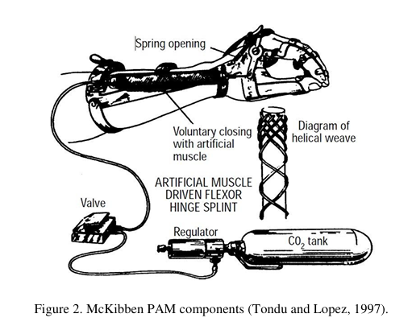
Derivation For Pressure and Force Relation:

In a first approach toward the model of a McKibben type PAM, losses are not considered and thus, the gas enters the PAM and expands, generating a traction force and a work. To generate the volume increase, the gas performs a work input (Win) that can be described.
$$dWin = ∫(P - Pex )dli.dSi$$
$dWin = (P - Pex) ∫dli.dSi$
$$dWin = P’dV$$
Where,
$Pex = External Force$,
$$P = Absolute Pressure$$
$$P’ = Relative/Gauge Pressure$$
As the pressure performs work by volume expansion and it is assumed that the system has no loss, all the work is converted into traction and can be expressed by Wout,
$dWout = -FdL$
Where, F is the axial tension and dL is the displacement.

The Conservation of Energy gives:
$dWin = dWout$
$$P’dV = -FdL$$
$F = - P’ \frac{dV}{dL}$ ........................ (1)
With the strength defined in terms of the volume change, just missing define the volume variation permitted by the mesh. The variation stops when volume reaches its maximum. At this moment, the muscle reaches the largest contraction.

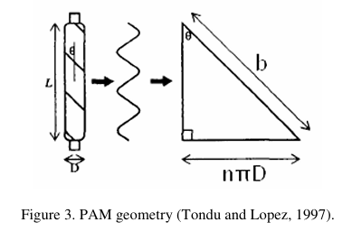

Observing Fig.3, it is possible to make the length (L) and diameter (D) as a function of the angle (θ). This angle is one formed between the mesh and the axial length of the muscle. The length of fiber can be named b and n is the number of turns of the fiber around the muscle. Using b and n, it is possible to set the length and the diameter of the muscle.
$cosθ= \frac{L}{b}$ …………………………... (1)
$L = b cos$….……………………..… (2)
$sinθ =\frac{Dnπ}{b}$
$D= \frac{bsinθ}{nπ}$ …………….…….………. (3)
Making the Volume equation as function of the diameter and D & length L.
$V= \frac{1}{4}*πD^{2}L$ ………………………. (4)

By substituting D & L in eq 4
We get,
$V= \frac{b^{3}}{4πn^{2}} *\left[\sin^{2}θ*cosθ\right]$……... (5)
Diff. eq (2) & eq (5) w. r. t. θ
$\frac{dL}{dθ}=-bsinθ$ …….…..……………………. (6)
$\frac{dV}{dθ}= \frac{b^{3}}{4πn^{2}} *[3\cos^{2}θ -1]$ …….………. (7)
Substitute the value of eq (6) & eq (7) in eq (1)
$F=-P^{'}* \frac{dV}{dL}=-P^{'}* \frac{\frac{dV}{dθ}}{\frac{dL}{dθ}}$
After substituting and rearranging, we get:
$F= \frac{P^{'}D^{2} (3\cos^{2}θ -1)}{4πn^{2}}$ ……………………... (8)
$D= \frac{bsinθ}{nπ}$
$\frac{D}{sinθ}= \frac{b}{nπ}$
By substituting the value of D & trigonometric relation in eq (8)
$F= \frac{π}{4} P^{'}D^{2}* \frac{(3\cos^{2}θ -1)}{\sin^{2}θ}$ ……………….. (9)
Adopting contraction (ε) and applying Eq.9, it is possible to reach to required formulation (Daerden and Lefeber, 2000).
$D= \frac{bsinθ}{nπ}$ …………… (After applying pressure)
$D_{0}= \frac{bsinθ_{0}}{nπ}$ ………...... (Before applying pressure)
$D = D_{0}$………. Basic Interpretation
So, we can replace D & sinθ with D0 & sinθ0 in eq (9)
$cosθ= \frac{L}{b}$
$L = b cosθ$
$L_{0}= b cosθ_{0}$
$\frac{L}{L_{0}}= \frac{cosθ}{cosθ_{0}}$
By Rearranging,
$cosθ= \frac{L}{L_{0}} {cosθ}_{0}$ ……………………………. (10)
Where, Contraction Factor (ε)
$$ε= \frac{L_{0}-L}{L_{0}}=1 - \frac{L}{L_{0}}$$
$1-ε= \frac{L}{L_{0}}$
Put this value in eq (10)
$cosθ=(1-ε){ * cosθ}_{0}$
Substitute cosθ, D = D_{o} & sinθ = sinθ_{o} in eq (9)
$F= \frac{π}{4} P^{'}D^{2}* \frac{(3{(1-ε)}^{2}{ * \cos^{2}θ}_{0}-1)}{\sin^{2}θ_{0}}$ ………………… (11)
This Calculations for Static Conditions
By rearranging eq (11) and converting it into bar,
$P^{'}= \frac{F*4*\sin^{2}θ_{o}}{π*D^{2}*\left(3{\left(1-ϵ\right)}^{2}*\cos^{2}θ_{o}-1\right)*{10}^{5}}$ …………………………… (12)
Losses:
There are various losses in calculating force, such as Braid Friction loss, Bladder elasticity loss, Hydraulic Pressure Loss, End Fitting and seal loss, and much more. But this are main losses that are considered.
$$F_{loss}=F_{f}+F_{e}+F_{h}+F_{s}$$
Where,
Terms | Description
$$F_{f}$$ | Braid friction loss
$$F_{e}$$ | Bladder elasticity loss
$$F_{h}$$ | Hydraulic pressure loss
$$F_{s}$$ | End fitting and sealing loss

If we want to calculate the practical force which we have to require,
$$F_{practical}= \frac{P D_{0}^{2}}{4\sin^{2}θ_{0}}*\left(3{\left(1-ε\right)}^{2}\cos^{2}θ -1\right)-(F_{f}-F_{e}-F_{h}-F_{s})$$
- Braid Friction loss:
$$F_{f}​=μ_{b}​PπDL$$
Where,
Symbol | Meaning
$$μ_{b}$$ | Braid friction coefficient
$$P$$ | Hydraulic pressure
$$D$$ | Actuator diameter
$$L$$ | Active actuator length

- Bladder elasticity loss:
$$F_{e}​=EAε$$
Where,
Symbol | Meaning
$$E$$ | Young's modulus of bladder
$$A$$ | Cross-sectional area of bladder wall
$$ε$$ | Axial strain

Area: $A=\frac{π}{4}\left(D_{o}^{2}-D_{i}^{2}\right)$
Where, $D_{o}$and $D_{i}$are the outer and inner diameters.
- Hydraulic Pressure Loss:
$$F_{h}​=ΔPA_{i}$$
Pressure drop: $ΔP=f\frac{L_{h}}{D_{h}}\frac{ρv^{2}}{2}$
Symbol | Meaning
$$f$$ | Darcy friction factor
$$L_{h}$$ | Hose length
$$D_{h}$$ | Hose inner diameter
$$ρ$$ | Fluid density
$$v$$ | Fluid velocity
$$A_{i}$$ | Internal fluid area
Internal area: $A_{i}=\frac{πD_{i}^{2}}{4}$
- End Fitting and seal loss:
$$F_{s}=μ_{s}​N$$
Symbol | Meaning
$$μ_{s}$$ | Seal friction coefficient
$$N$$ | Normal force on seal
Let us consider, by combining all the losses in force be 30%, which simplifies our further calculation and makes easy to calculate.
Calculations:
By using this Formula:
$F= \frac{π}{4} P^{'}D^{2}* \frac{(3{(1-ε)}^{2}{ * \cos^{2}θ}_{0}-1)}{\sin^{2}θ_{0}}$
We can get the Force and Pressure relation.
Actuator Parameters For test trial 1:
- Length of bladder: 300mm (complete length), 250mm (active length) (we can take any length as the calculation for 0 to infinity)
$L = 300mm = 0.3m$
- Diameter of bladder: by calculation go upto 60mm diameter, for trial we will go for 40mm
$D = 40mm = 0.04m$
- Contraction factor: $ε=\text{0.2 to 0.25}$
- Operating Pressure: 0 to 6 bar
- Force That required to lift the minimum of 5kg of payload
$F = 5*9.81 = 49.05 N$
- So, considering the required force is 10 times of payload,
$$F = 10*5*9.81 = 490.5 N$$
After using this Formula:
$F= \frac{π}{4} P^{'}D^{2}* \frac{(3{(1-ε)}^{2}{ * \cos^{2}θ}_{0}-1)}{\sin^{2}θ_{0}}$
We can determine the pressure value:
$P^{'}= \frac{F*4*\sin^{2}θ_{o}}{π*D^{2}*\left(3{\left(1-ϵ\right)}^{2}*\cos^{2}θ_{o}-1\right)*{10}^{5}}$
On D = 0.04m, θo = 20° , ε = 0.2 and F = 490.5 N
$$P’ = 0.656 bar$$
On D = 0.04m, θo = 20° , ε = 0.25 and F = 490.5N
$$P’ = 0.932 bar$$
On D = 0.04m, θo = 25° , ε = 0.2 and F = 490.5N
$$P’ = 1.208 bar$$
On D = 0.04m, θo = 25° , ε = 0.25 and F = 490.5N
$$P’ = 1.805 bar$$
Considering efficiency of 30% of maximum obtained value,
$$P’max = 2.34 bar$$

Braid Angle Calculation:
Initial Braid Angle:
$$θ_{0}=20°$$
Formula to calculate Final Braid Angle:
$$cosθ=(1-ε){ * cosθ}_{0}$$
Let Contraction Factor be calculated with,
$$ε= \frac{L_{0}-L}{L_{0}}$$
We have,
Initial Length: L₀ = 250mm
And Contracted Length: L = 200mm
$$ε= \frac{250-200}{250}=0.2$$
Now calculate Final Braid Angle:
$$cosθ=(1-ε){ * cosθ}_{0}$$
$$cosθ=\left(1-0.2\right)*\cos\left(20\right)=0.7517$$
$$θ=41.26°$$
Similarly, we can calculate from angle 5° to 54°.
The things which have to keep in mind,
We want linear contraction and radial expansion.
If,
θ < 54.7° (Linear Contraction and radial expansion)
θ > 54.7° (Linear expansion and radial Contraction)
θ = 54.7° (Critical Value)
As we calculated for Initial Braid Angle 20° and Contraction Factor 0.2, there are further calculation in the table, and there is also a graphical representation of the angles and how they approach to the critical line which is 54.7° line.

Graphical Calculation:
Initial Braid Angle (Degree) | Final Braid Angle
Initial Braid Angle (Degree) | (Contraction Factor)
Initial Braid Angle (Degree) | 0.2 | 0.25 | 0.3 | 0.35
5 | 37.16 | 41.66 | 45.79 | 49.64
10 | 38.02 | 42.39 | 46.42 | 50.20
15 | 39.40 | 43.58 | 47.46 | 51.11
20 | 41.26 | 45.19 | 48.87 | 52.35
25 | 43.53 | 47.18 | 50.62 | 53.91
30 | 46.15 | 49.49 | 52.68 | 55.74
35 | 49.06 | 52.09 | 55.01 | 57.83
40 | 52.21 | 54.93 | 57.57 | 60.14
45 | 55.55 | 57.97 | 60.33 | 62.64
50 | 59.05 | 61.18 | 63.26 | 65.30
54 | 61.95 | 63.84 | 65.70 | 67.54
54.7 | 62.47 | 64.32 | 66.14 | 67.94

Graphical Representation of Final Braid Angle vs Initial Braid Angle

Different Iterations on diameter variation:
Iteration 1:
Initial  Braid  Angle  (θ0)  (Degree) | Pressure in bar |  |  |  | Pressure Value (Logarithmic)
Initial  Braid  Angle  (θ0)  (Degree) | (Contraction Ratio) |  |  |  | (Contraction Ratio)
Initial  Braid  Angle  (θ0)  (Degree) | 0.2 | 0.25 | 0.3 | 0.35 | 0.2 | 0.25 | 0.3 | 0.35
5 | 0.320 | 0.430 | 0.632 | 1.125 | -0.494 | -0.366 | -0.199 | 0.051
10 | 1.336 | 1.809 | 2.706 | 5.023 | 0.126 | 0.257 | 0.432 | 0.701
15 | 3.233 | 4.454 | 6.887 | 14.013 | 0.510 | 0.649 | 0.838 | 1.147
20 | 6.425 | 9.117 | 14.992 | 37.475 | 0.808 | 0.960 | 1.176 | 1.574
25 | 11.822 | 17.670 | 32.886 | 165.924 | 1.073 | 1.247 | 1.517 | 2.220
30 | 21.703 | 35.950 | 93.164 | -193.403 | 1.337 | 1.556 | 1.969 | 2.286
35 | 43.582 | 94.964 | -922.975 | -84.060 | 1.639 | 1.978 | 2.965 | 1.925
40 | 124.561 | -1621.285 | -114.889 | -61.601 | 2.095 | 3.210 | 2.060 | 1.790
45 | -477.465 | -122.231 | -72.070 | -52.146 | 2.679 | 2.087 | 1.858 | 1.717
50 | -108.441 | -74.034 | -57.089 | -47.061 | 2.035 | 1.869 | 1.757 | 1.673
54 | -74.261 | -59.955 | -50.801 | -44.478 | 1.871 | 1.778 | 1.706 | 1.648
54.7 | -70.895 | -58.286 | -49.971 | -44.113 | 1.851 | 1.766 | 1.699 | 1.645

- Pressure becomes negative when the braid angle is 54.7° or more.
- The actuator works safely below 54.7°.
- A 25° initial braid angle is selected because it remains safe up to 35% contraction strain.
- The actuator shows linear contraction below 54.7° and tends to expand above 54.7°.
- Theoretical analysis was also carried out for actuator diameters of 16, 20, 25, 30, 40, 50, and 60 mm.
- By this way we can determine with multiple iterations.
Graphical Representation of Initial Braid Angle vs Logarithmic Value of Pressure on contraction factor 0.2 or 20%

Graphical Representation of Initial Braid Angle vs Logarithmic Value of Pressure on contraction factor 0.25 or 25%

Graphical Representation of Initial Braid Angle vs Logarithmic Value of Pressure on contraction factor 0.3 or 30%

Graphical Representation of Initial Braid Angle vs Logarithmic Value of Pressure on contraction factor 0.35 or 35%

Theoretical & Practical Pre-testing:
Formula
$$ΔL_{th}=ε×L_{0}$$
Given Data
- Active length, $L_{0}=120\text{ mm}$
- Contracted Length, L = 96 mm
- Contraction strain, $ε=20\%$
Calculation
$$ΔL_{th}=0.2×120=24\text{ mm}$$
Practical Test Results:
Pressure (bar) | NBR-Aramid (mm) | Silicone-Nylon (mm)
2 | 0 | 2
3 | 0 | 5
4.5 | — | 15
5 | 10 | 20
6 | 25 | —
10 | 30 | 20

In practical pre-testing we have used two different rubber tubes and two different braiding. And paired with each other to obtain deflection under the zero load.
Rubber Tubes:
- Silicon Rubber Tube (OD = 14mm, ID = 10mm)
- Nitrile Butadiene Rubber (NBR) Tube (OD = 12mm, ID = 10mm)
Braiding Material:
- Nilon 6 (ID = 16mm)
- Aramid (ID = 12.7mm)
Configuration and arrangement used:
- Silicon rubber tube with Nilon 6 Braiding
- NBR tube with Aramid Braiding
Fluid that used: HP Enklo 68
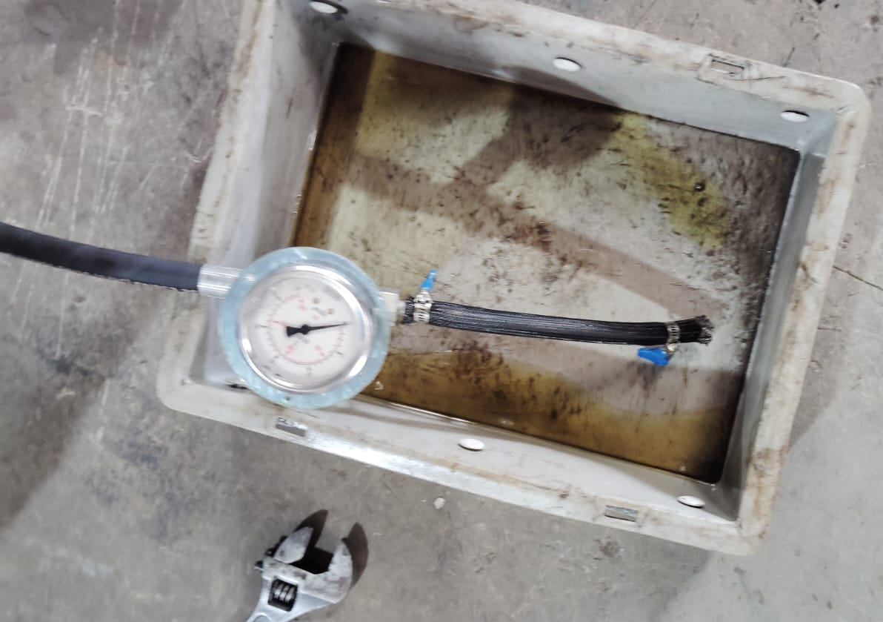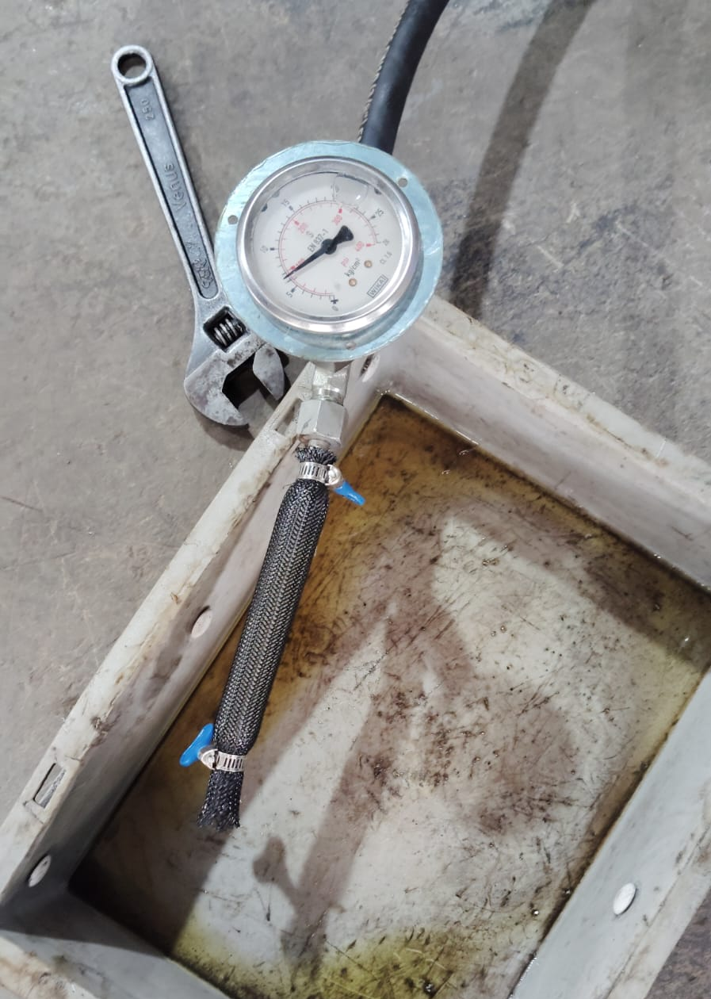
Before Contraction After Contraction
Graphical Representation (Pressure vs Stroke):

Graphical Representation (Pressure vs Contracted Length):

Maximum Length Change Comparison:
Type | Length Change (mm)
Theoretical | 24
NBR-Aramid | 30
Silicone-Nylon | 20

Images Of Pre-testing:
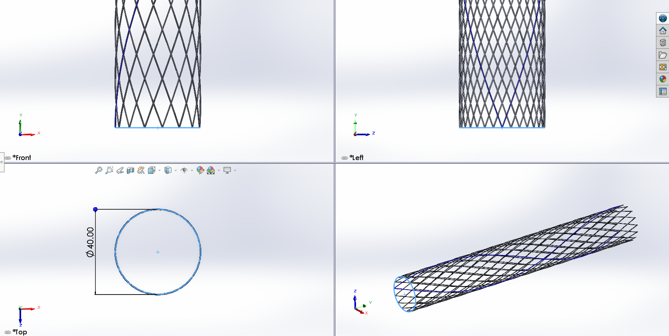
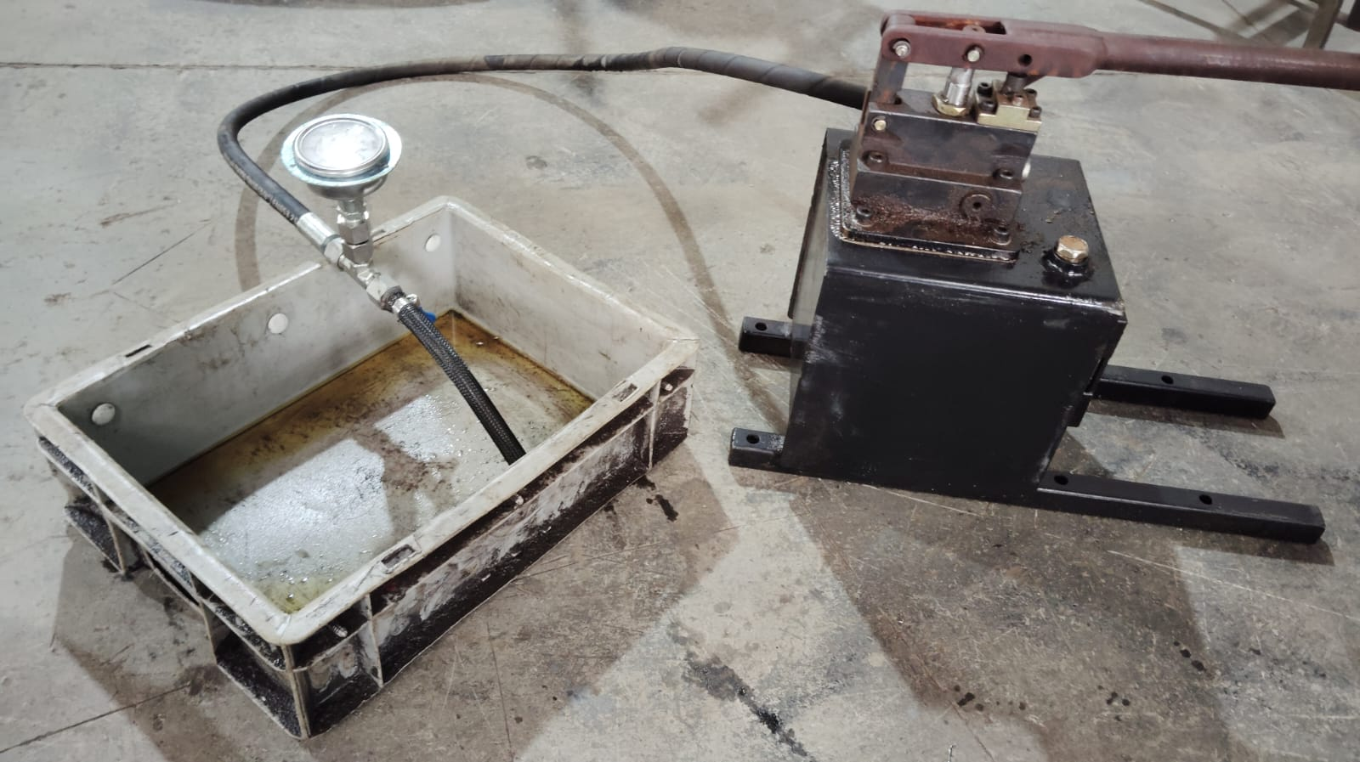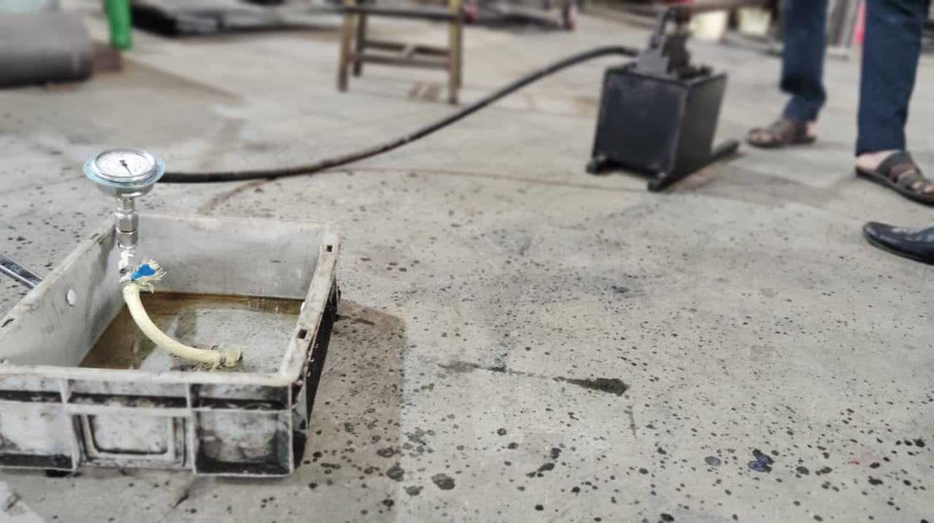
CAD Models:
HSA Sheath
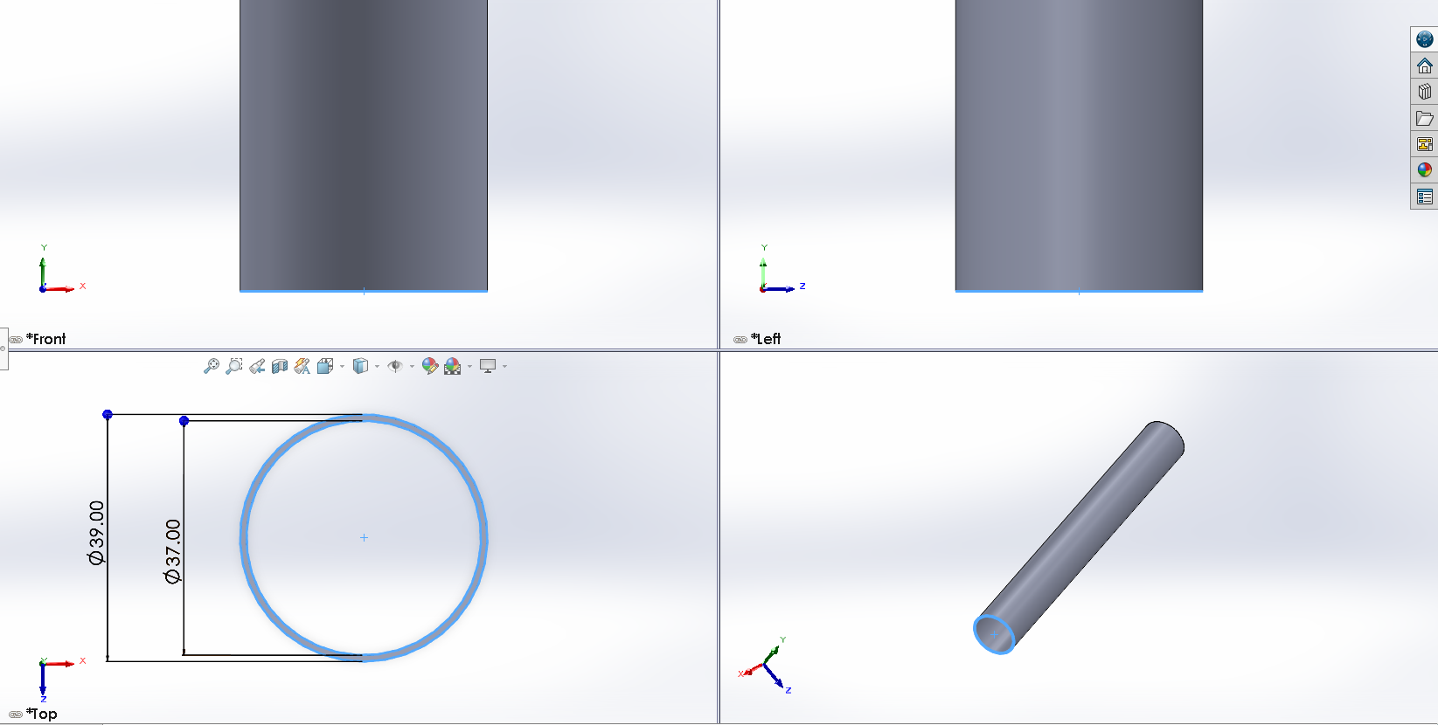
HSA Bladder

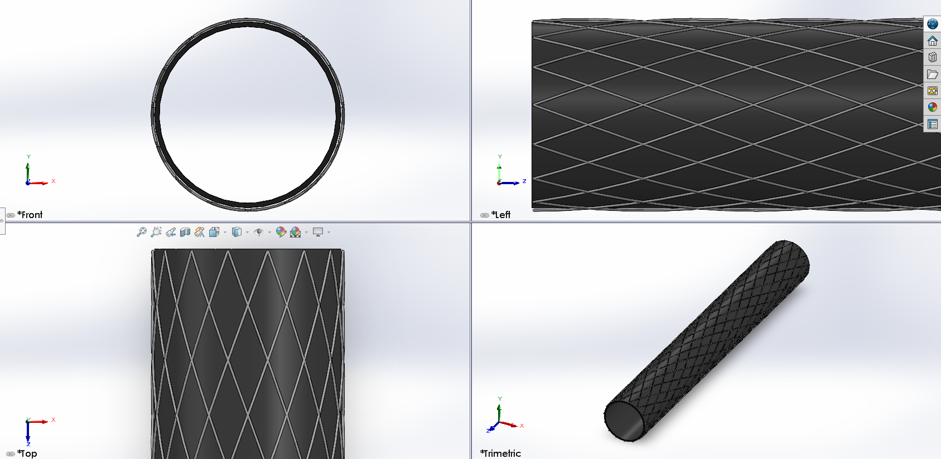
HSA Sheath And Bladder Mechanism

Rotating Mechanism for Arm:
We are planning to use rack and pinion mechanism, which a sector gear being a Forearm of the hand.
Further are some images of the gear mechanism which had done till now.
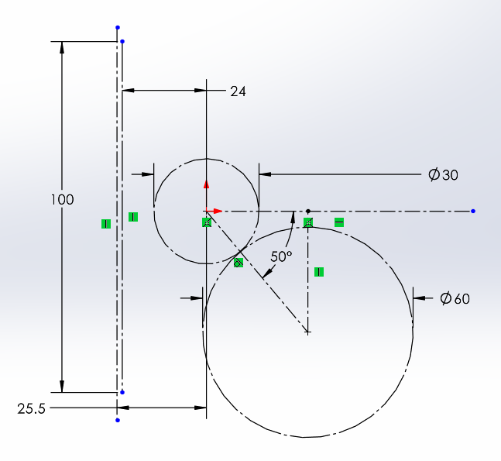
Reference Dimensions
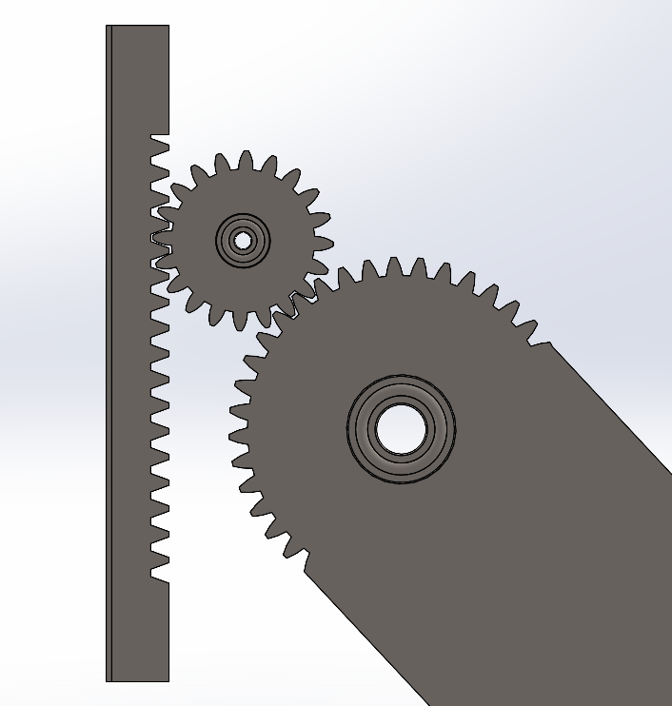
Sector Gear, Rack and Pinion arrangement
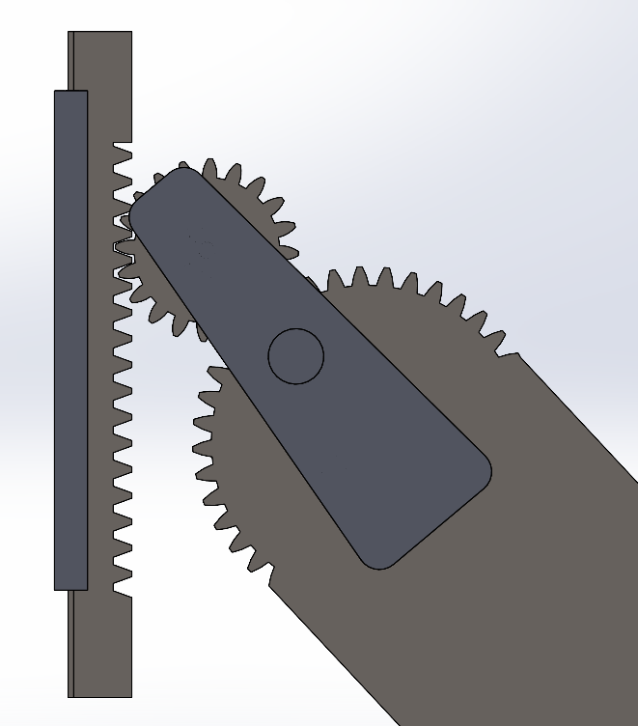
Image of guide and connector for gears and rack
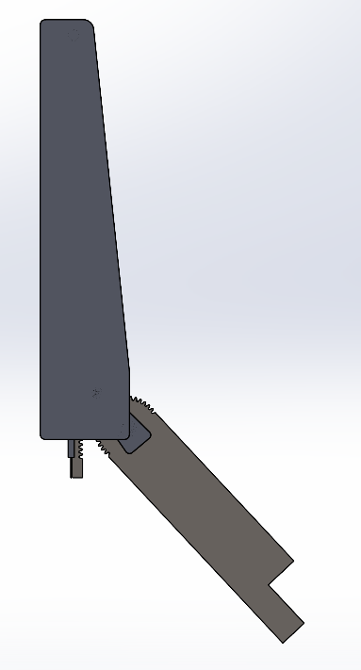
Complete arm mechanism
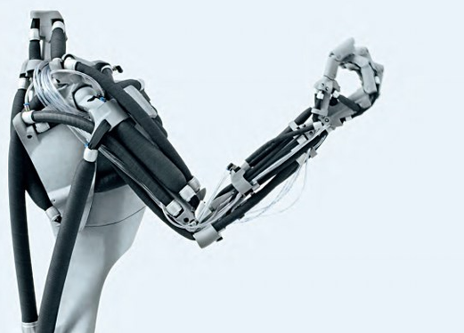
- This Kind of assembly we have to make:
Like mostly of Biceps and triceps, using hydraulic (Water/Oil) as a working fluid for actuate the muscle.
- Hence forth the mechanism and hydraulic power pack we have to design requiring for this actuator.
- And enabling it’s SDOF lifting.

